IT24101562

Jayawardana Y.M.G.S.V

01)

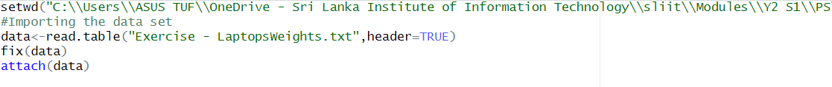

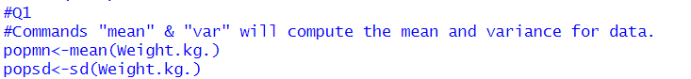



02)

03)

